**LAPORAN PROGRESS HACKERRANK**

**“PEMROGRAMAN WEB”**



Dosen Pengampu :

Asmunin, S.Kom., M.Kom.

Disusun Oleh :

Esti Ika Maharani (17051204019)

**PRODI S1.TEKNIK INFORMATIKA 2017 A**

**JURUSAN TEKNIK INFORMATIKA**

**FAKULTAS TEKNIK**

**UNIVERSITAS NEGERI SURABAYA**

* **SOAL-SOAL YANG SUDAH DIKERJAKAN**

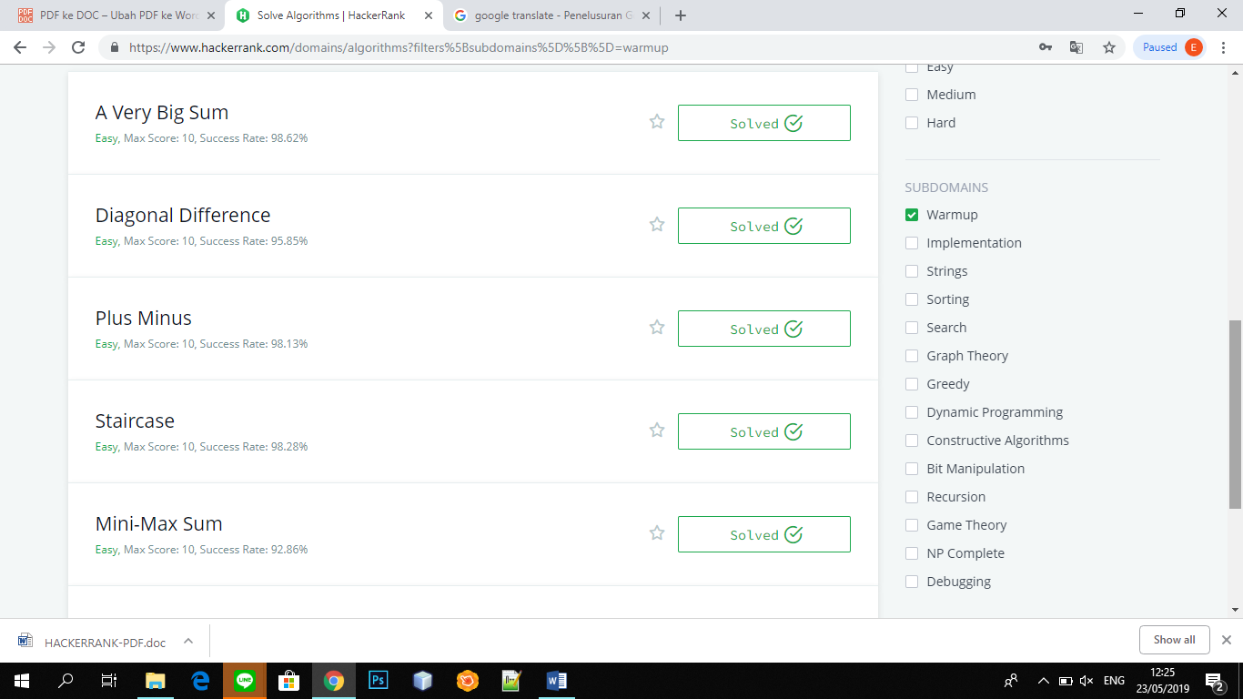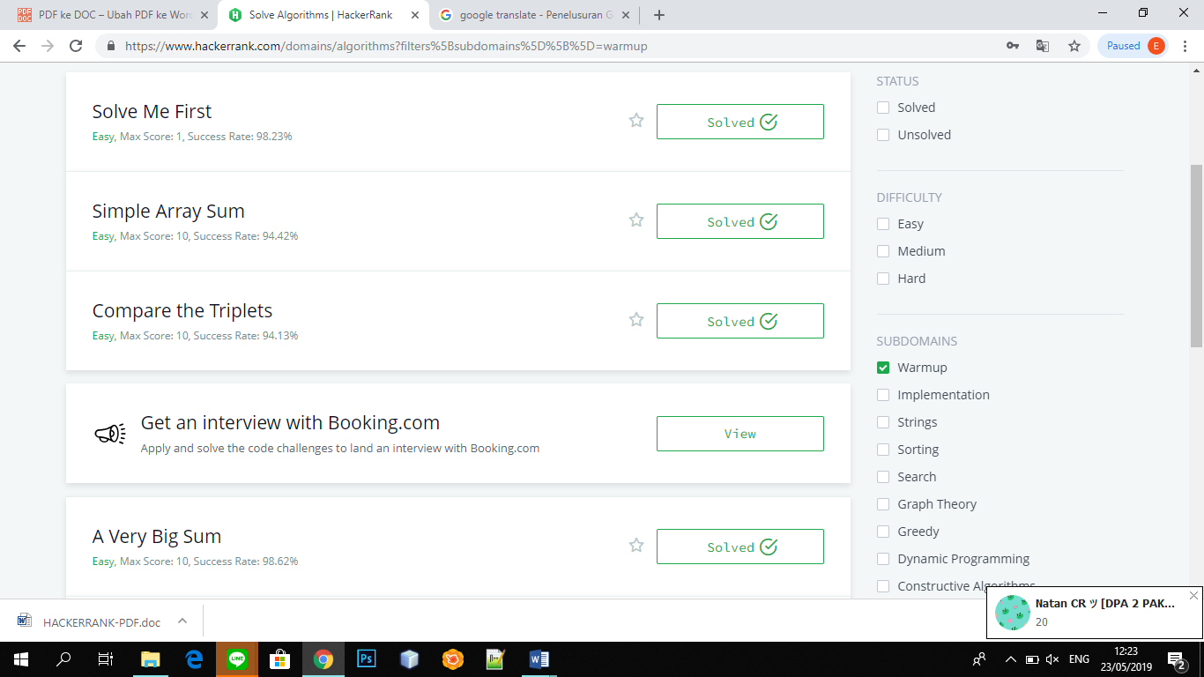

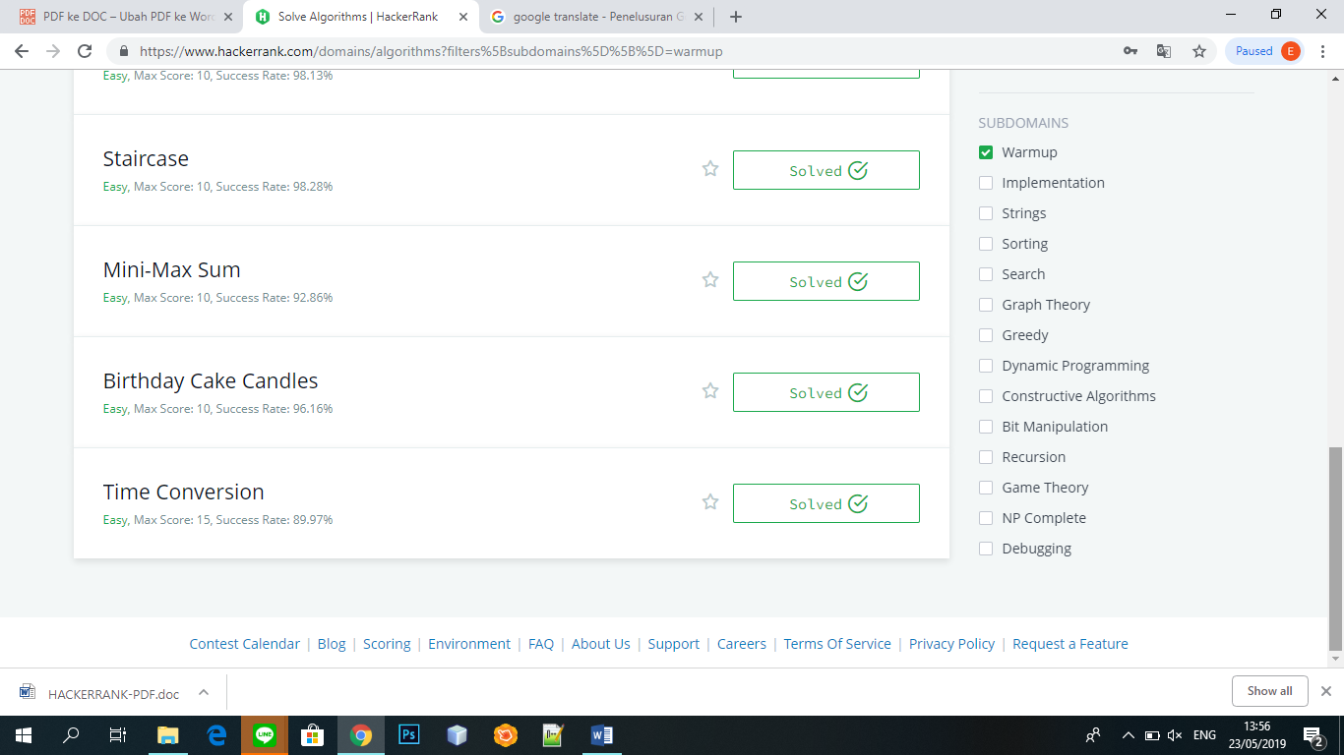

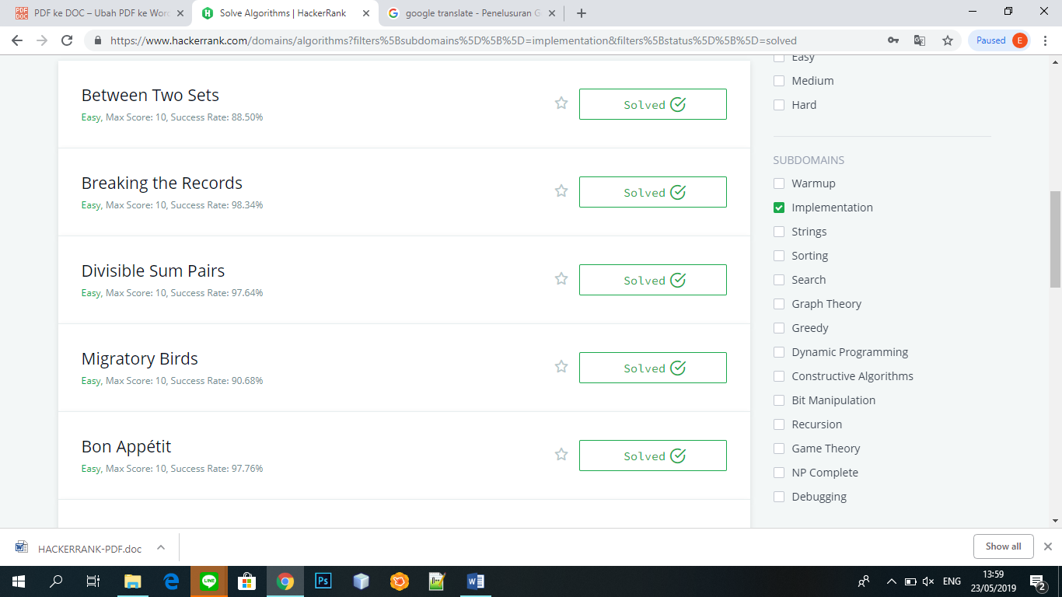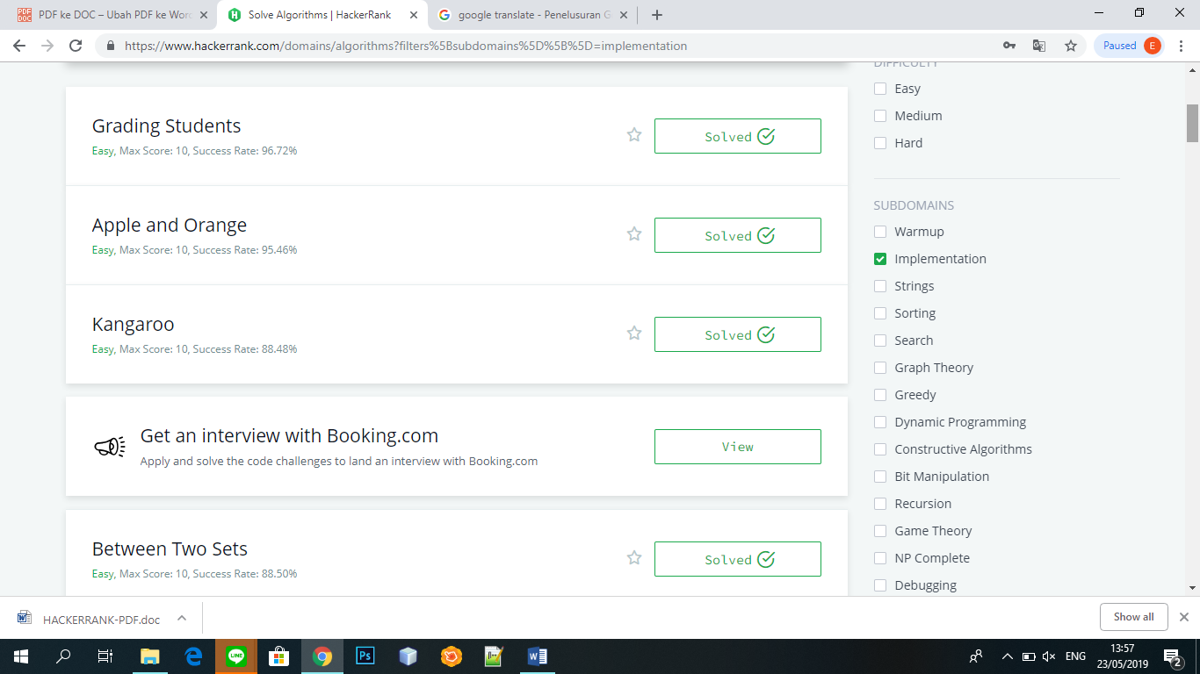

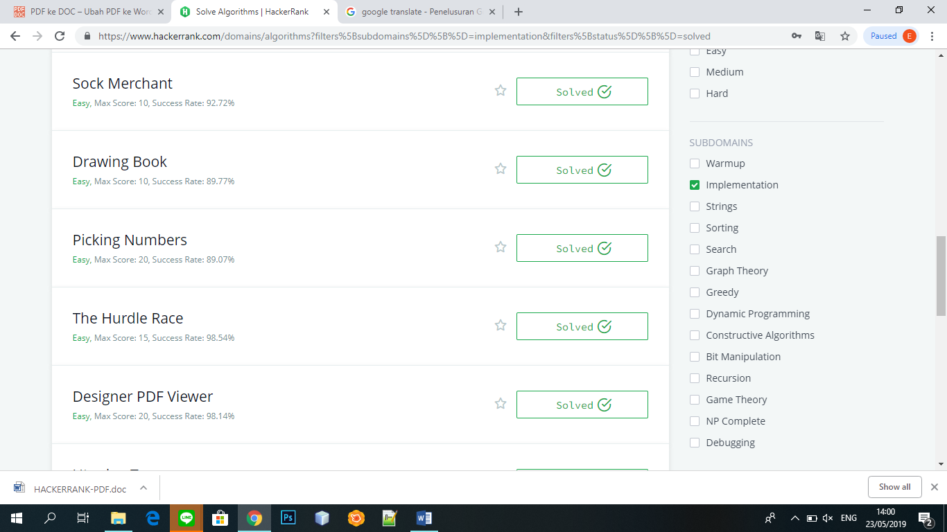

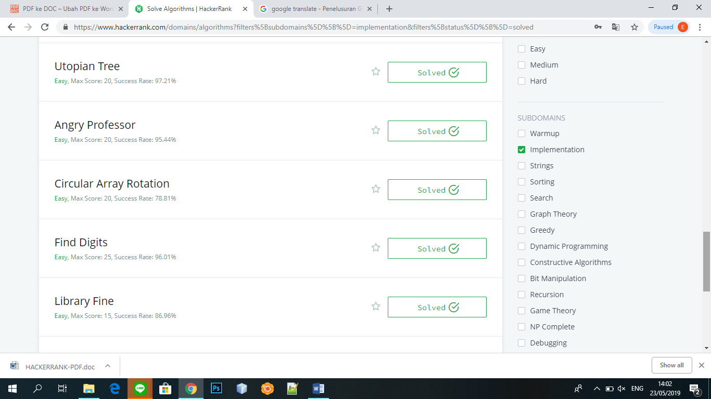

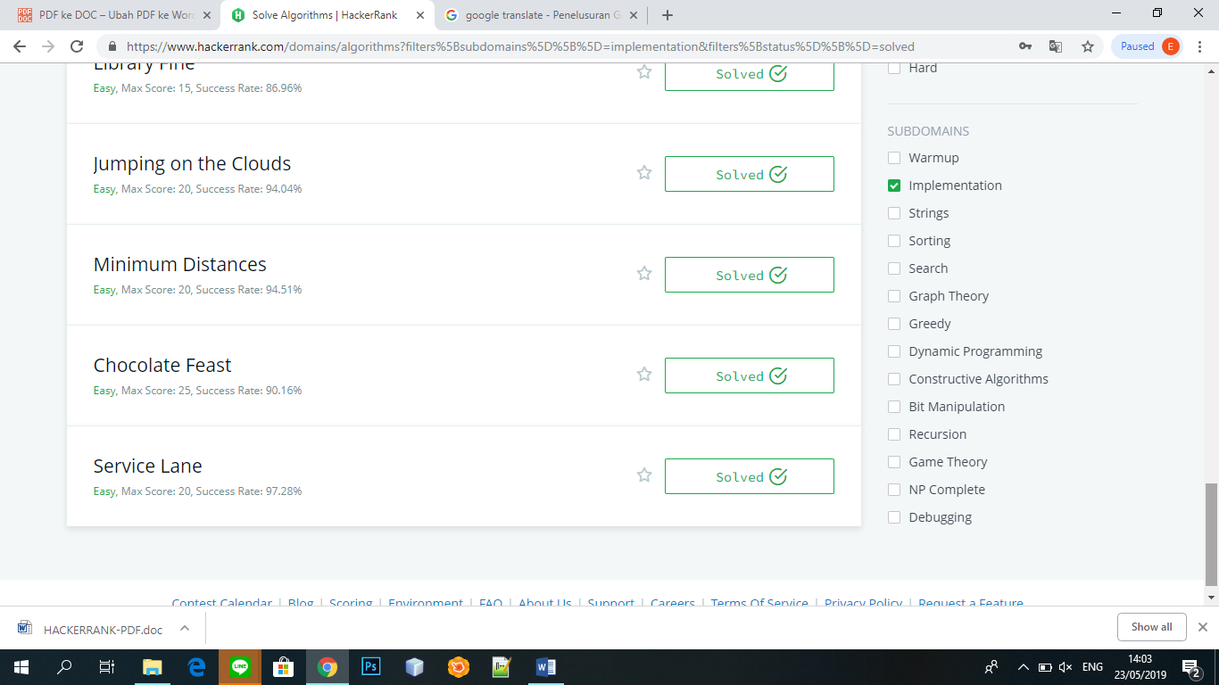

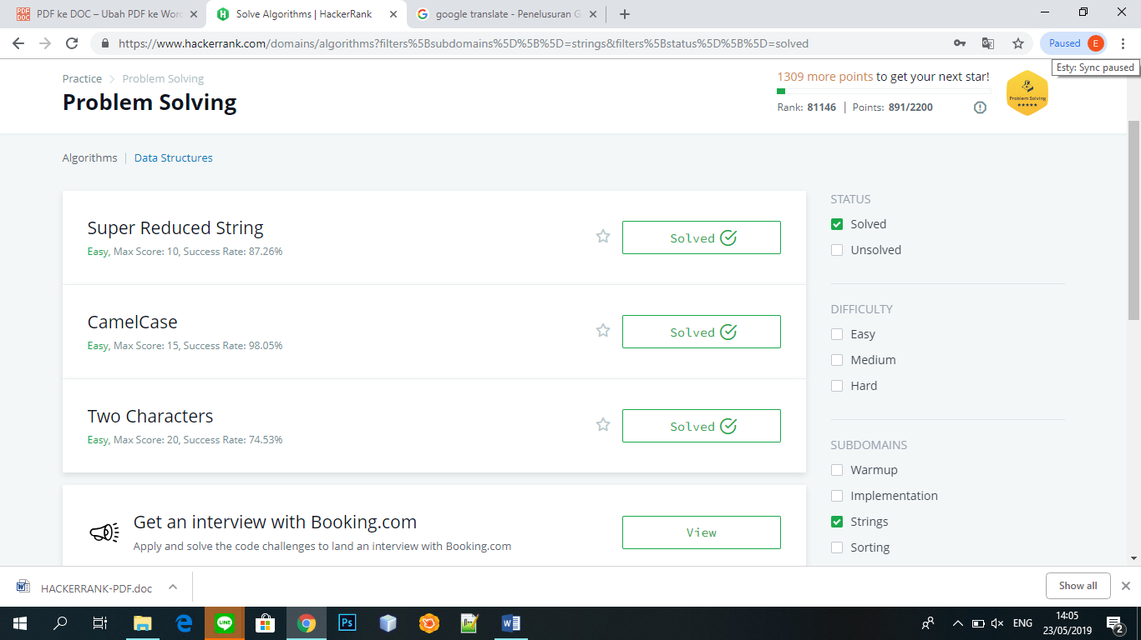

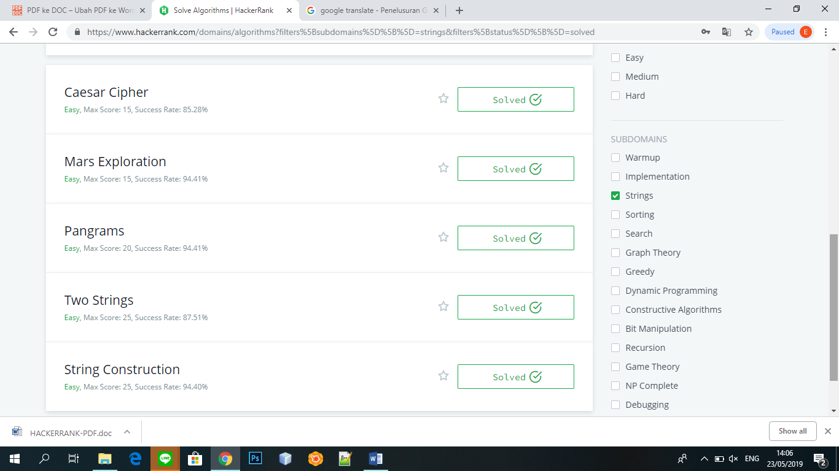

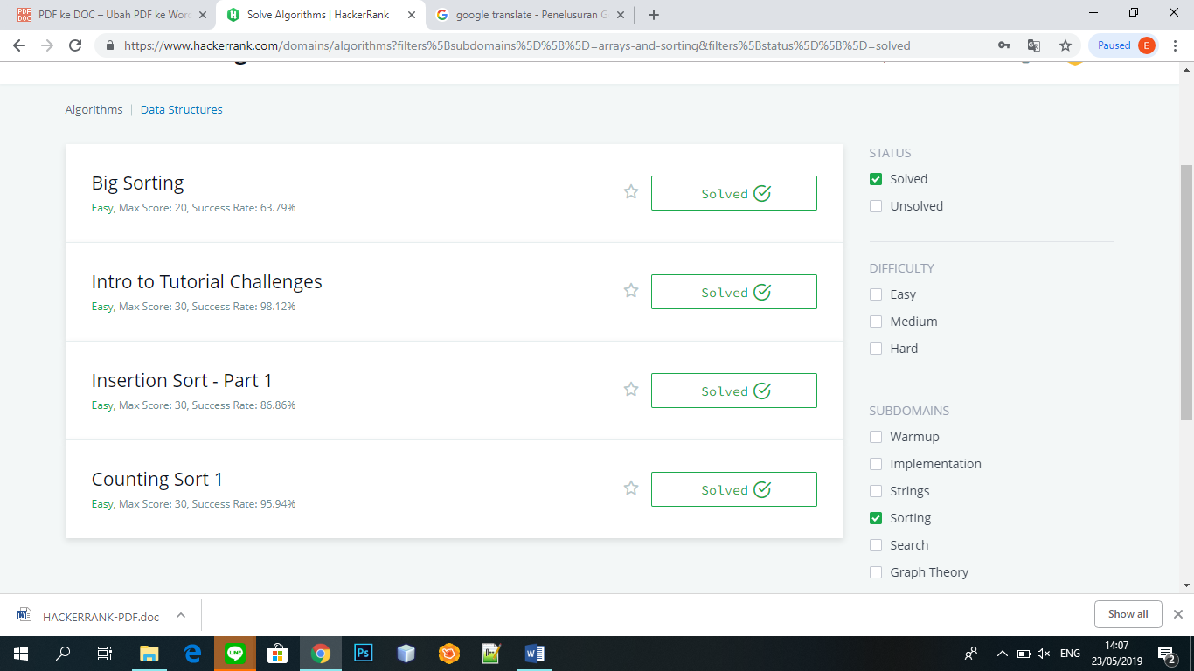

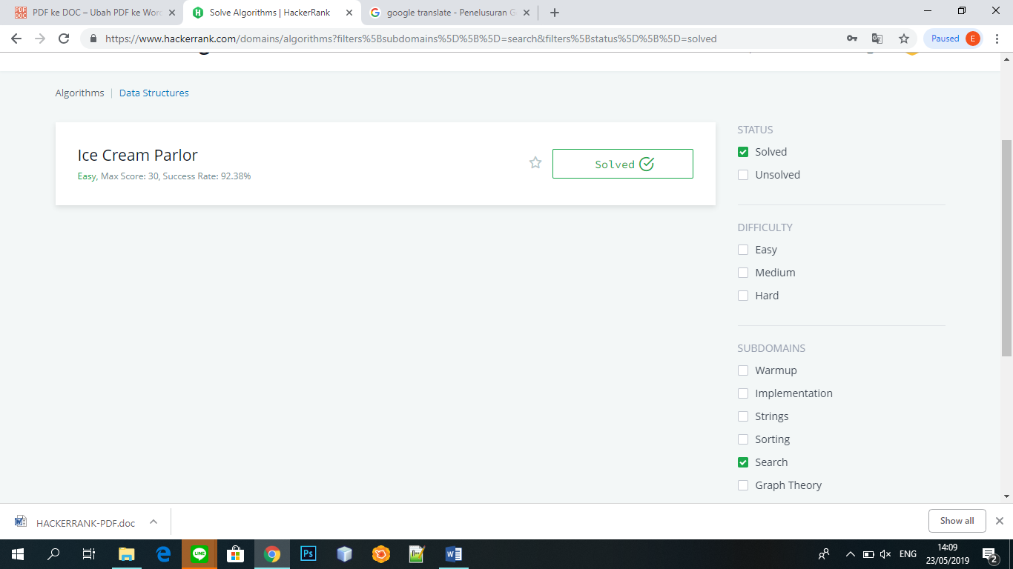

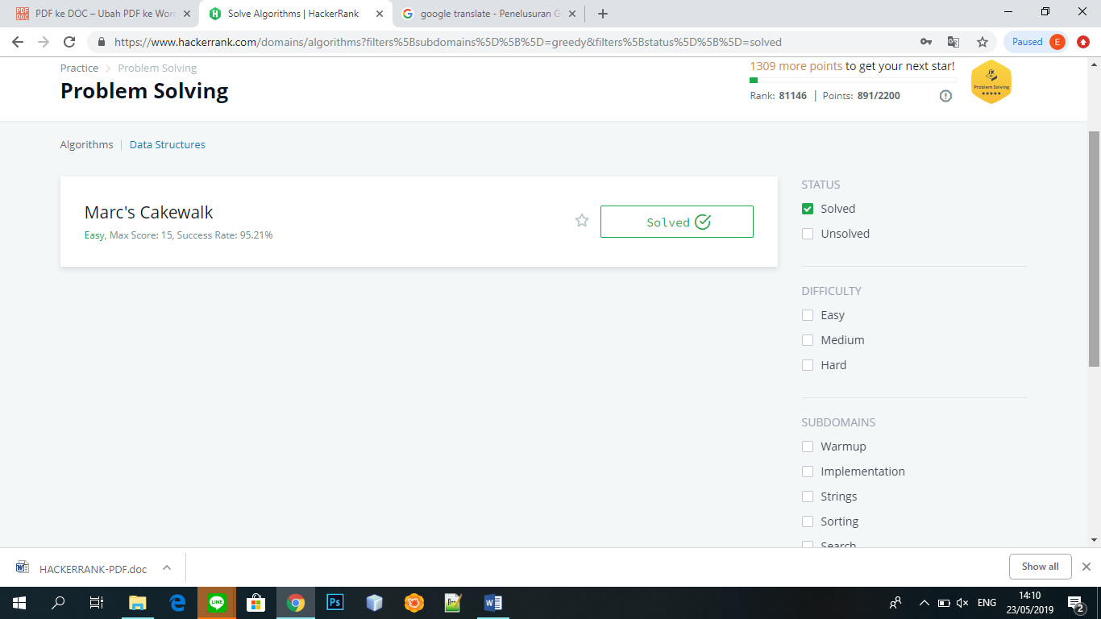

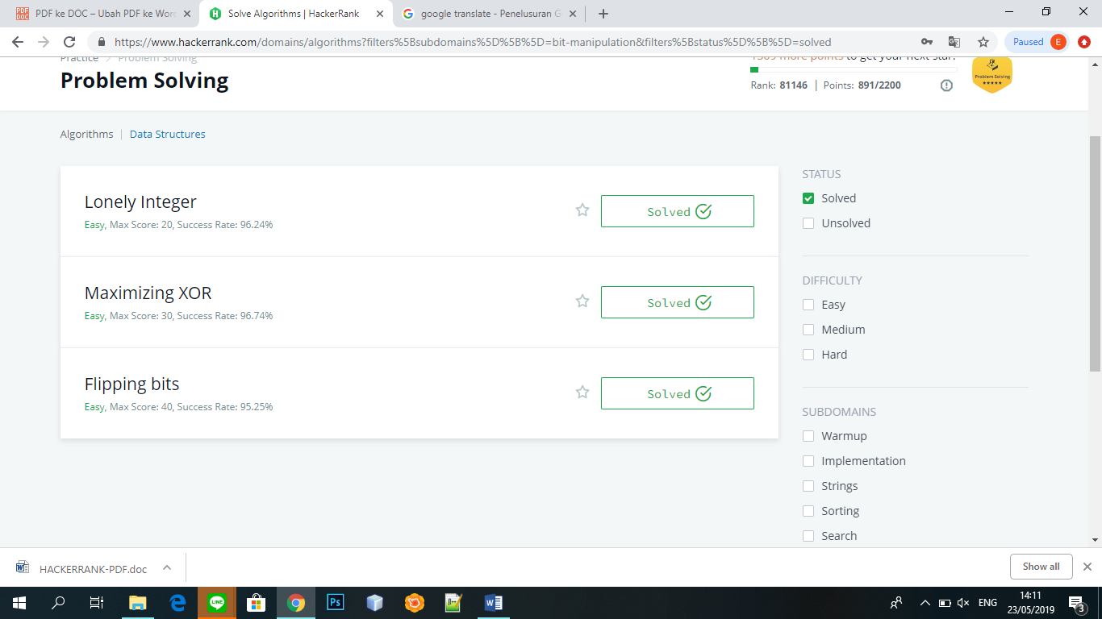

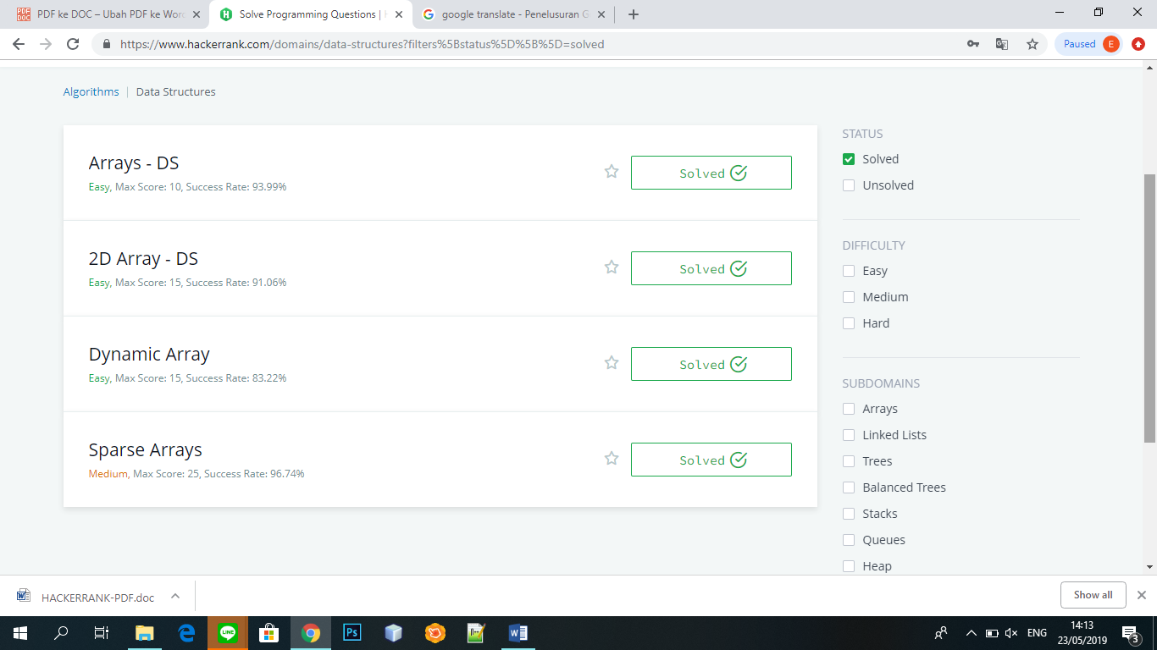

* **SOURCE CODE**
  + - 1. **Dinamic Array**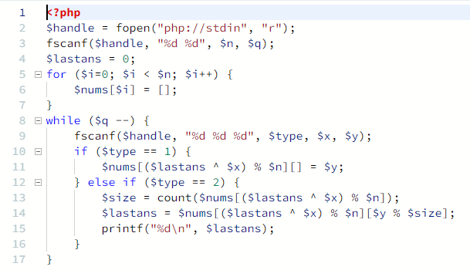
      2. **Sparce Arrays**

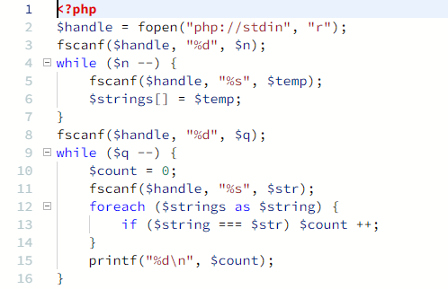**3. 2D-Array-DS**

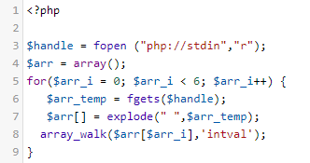

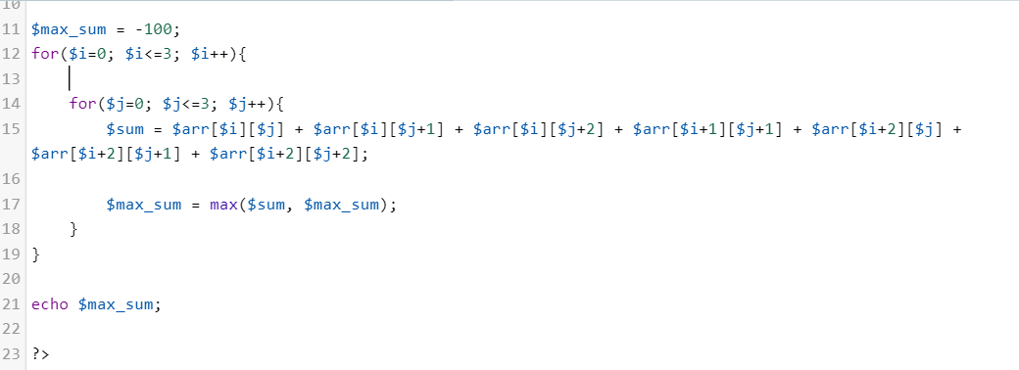

1. [**Arrays - DS**](https://www.hackerrank.com/challenges/arrays-ds)

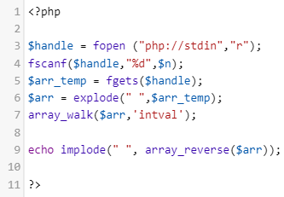

1. [**Flipping bits**](https://www.hackerrank.com/challenges/flipping-bits)

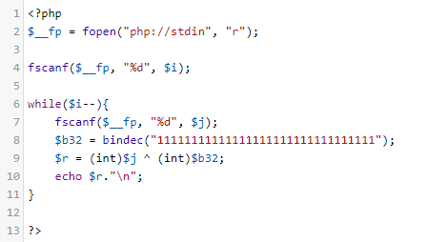

1. [**Maximizing XOR**](https://www.hackerrank.com/challenges/maximizing-xor)

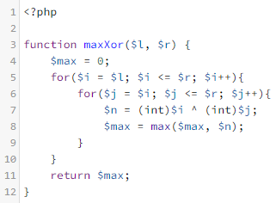

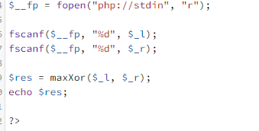

1. [**Lonely Integer**](https://www.hackerrank.com/challenges/lonely-integer)

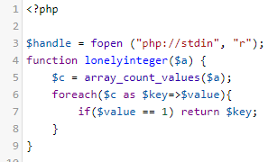

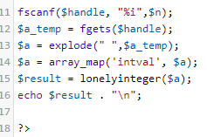

1. [**Marc's Cakewalk**](https://www.hackerrank.com/challenges/marcs-cakewalk)

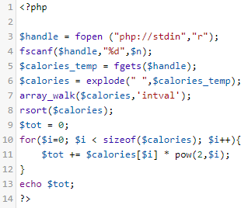

1. [**Ice Cream Parlor**](https://www.hackerrank.com/challenges/icecream-parlor)

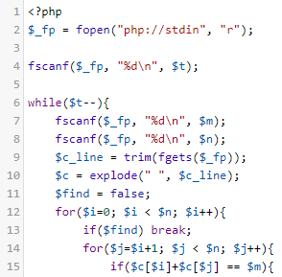

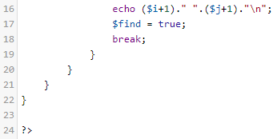

1. [**Counting Sort 1**](https://www.hackerrank.com/challenges/countingsort1)

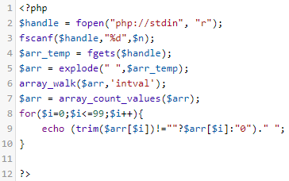

1. [**Insertion Sort - Part 1**](https://www.hackerrank.com/challenges/insertionsort1)

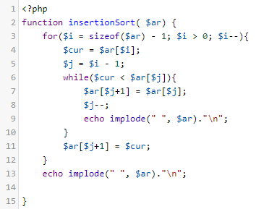

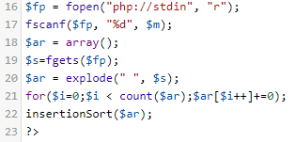

1. [**Intro to Tutorial Challenges**](https://www.hackerrank.com/challenges/tutorial-intro)

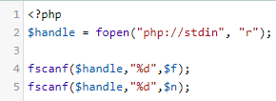

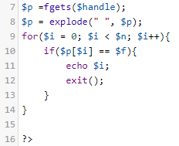

1. [**Big Sorting**](https://www.hackerrank.com/challenges/big-sorting)

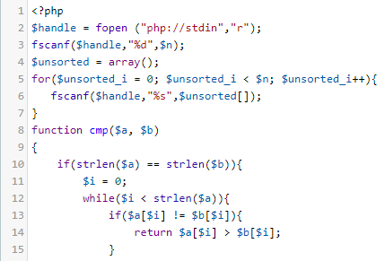

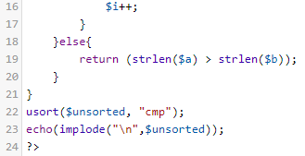

1. [**String Construction**](https://www.hackerrank.com/challenges/string-construction)

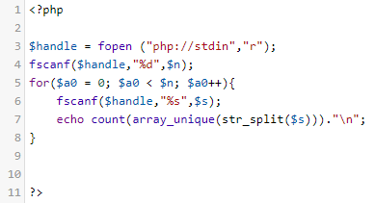

1. [**Two Strings**](https://www.hackerrank.com/challenges/two-strings)

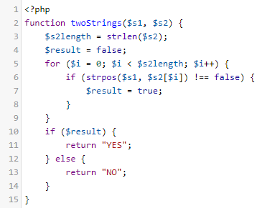

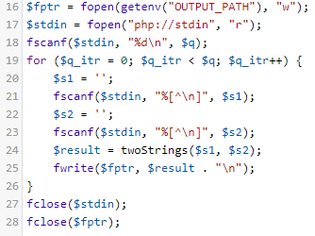

1. [**Pangrams**](https://www.hackerrank.com/challenges/pangrams)

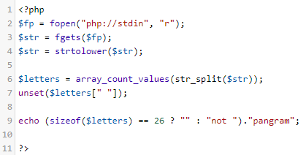

1. [**Mars Exploration**](https://www.hackerrank.com/challenges/mars-exploration)

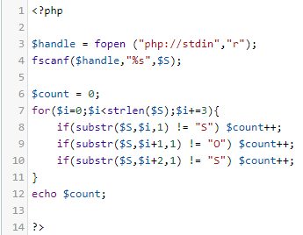

1. [**Caesar Cipher**](https://www.hackerrank.com/challenges/caesar-cipher-1)

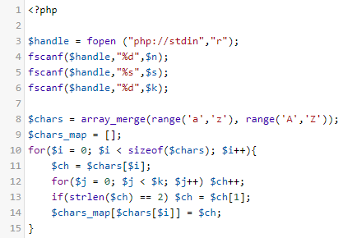

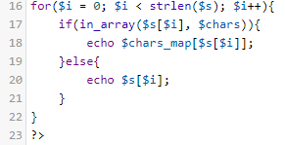

1. [**Two Characters**](https://www.hackerrank.com/challenges/two-characters)

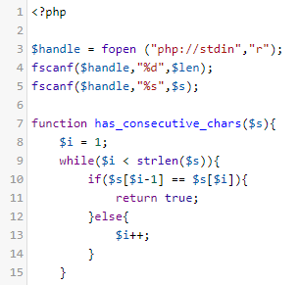

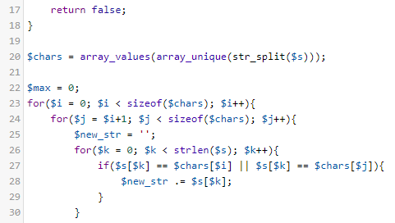

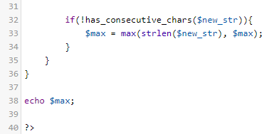

1. [**CamelCase**](https://www.hackerrank.com/challenges/camelcase)

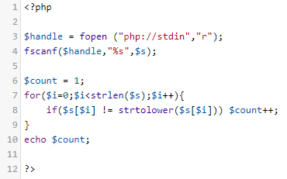

1. [**Super Reduced String**](https://www.hackerrank.com/challenges/reduced-string)

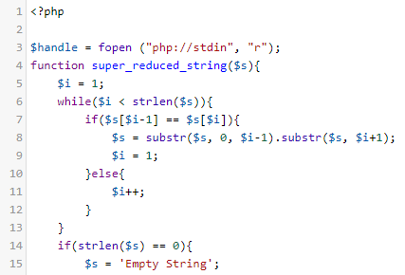

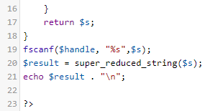

1. [**Service Lane**](https://www.hackerrank.com/challenges/service-lane)

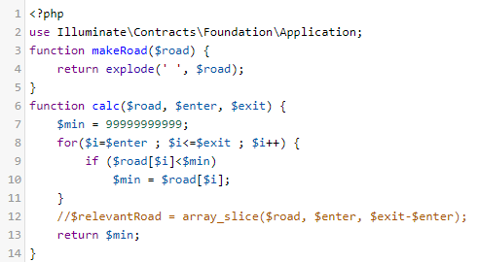

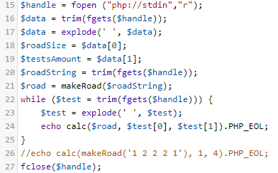

1. [**Chocolate Feast**](https://www.hackerrank.com/challenges/chocolate-feast)

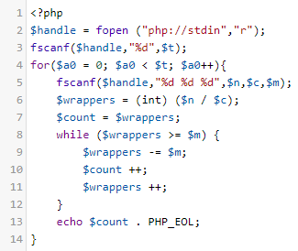

1. [**Minimum Distances**](https://www.hackerrank.com/challenges/minimum-distances)

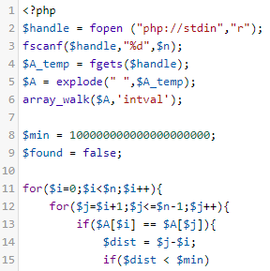

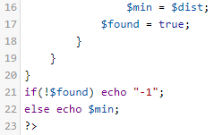

1. [**Jumping on the Clouds**](https://www.hackerrank.com/challenges/jumping-on-the-clouds)

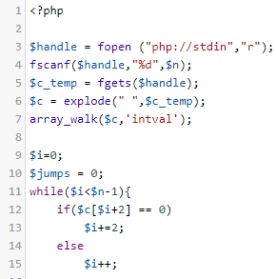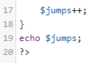

1. [**Circular Array Rotation**](https://www.hackerrank.com/challenges/circular-array-rotation)

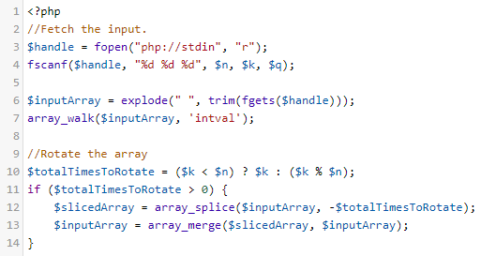

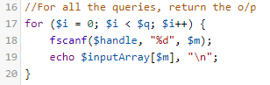

1. [**Library Fine**](https://www.hackerrank.com/challenges/library-fine)

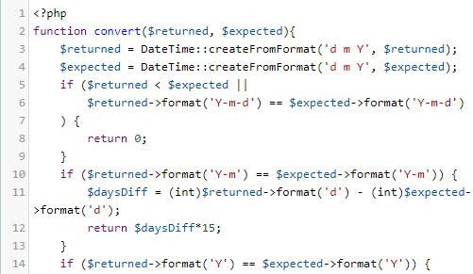

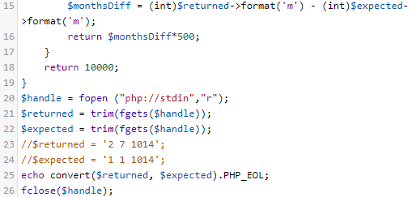

1. [**Find Digits**](https://www.hackerrank.com/challenges/find-digits)

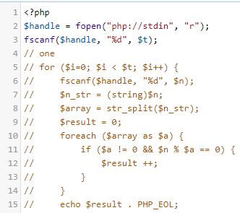

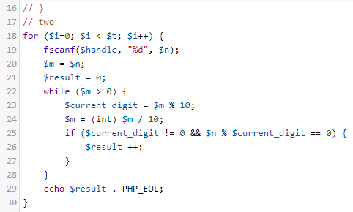

1. [**Angry Professor**](https://www.hackerrank.com/challenges/angry-professor)

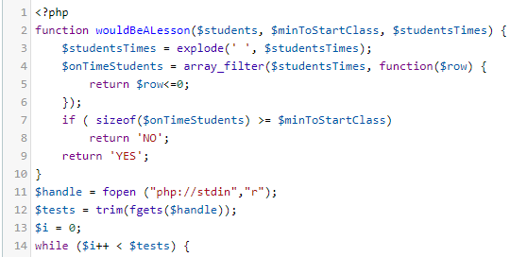

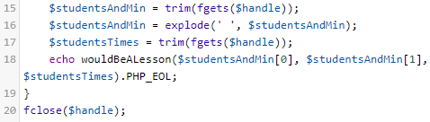

1. [**Utopian Tree**](https://www.hackerrank.com/challenges/utopian-tree)

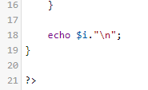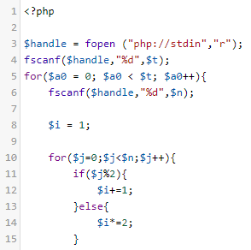

1. [**Designer PDF Viewer**](https://www.hackerrank.com/challenges/designer-pdf-viewer)

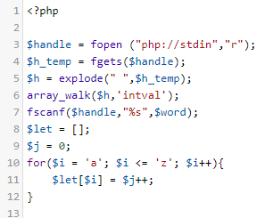

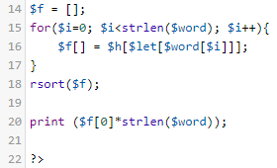

1. [**The Hurdle Race**](https://www.hackerrank.com/challenges/the-hurdle-race)

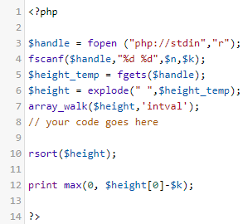

1. [**Picking Numbers**](https://www.hackerrank.com/challenges/picking-numbers)

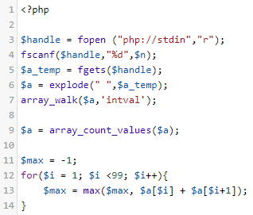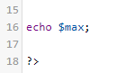

1. [**Drawing Book**](https://www.hackerrank.com/challenges/drawing-book)

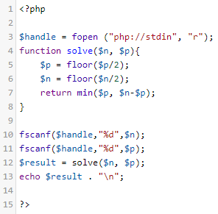

1. [**Bon Appétit**](https://www.hackerrank.com/challenges/bon-appetit)

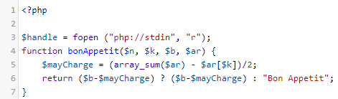

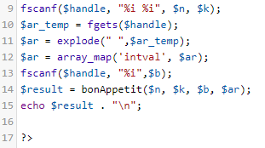

1. [**Migratory Birds**](https://www.hackerrank.com/challenges/migratory-birds)

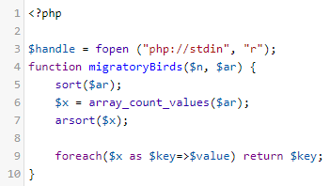

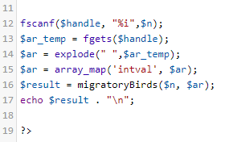

1. [**Divisible Sum Pairs**](https://www.hackerrank.com/challenges/divisible-sum-pairs)

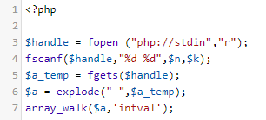

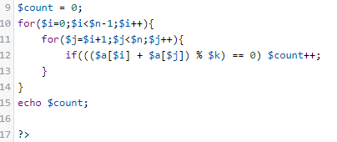

1. [**Breaking the Records**](https://www.hackerrank.com/challenges/breaking-best-and-worst-records)

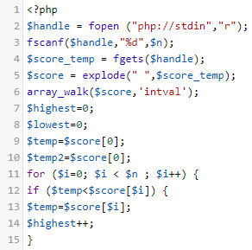

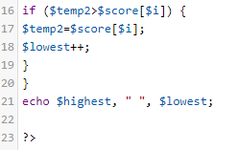

1. [**Between Two Sets**](https://www.hackerrank.com/challenges/between-two-sets)

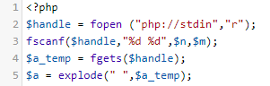

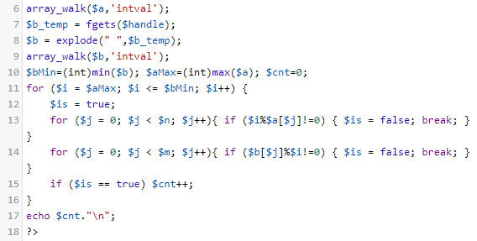

1. [**Kangaroo**](https://www.hackerrank.com/challenges/kangaroo)

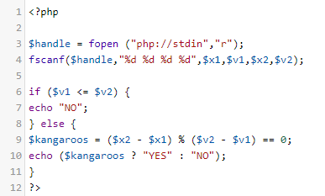

1. [**Apple and Orange**](https://www.hackerrank.com/challenges/apple-and-orange)

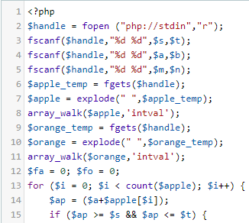

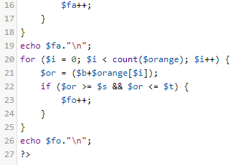

1. [**Grading Students**](https://www.hackerrank.com/challenges/grading)

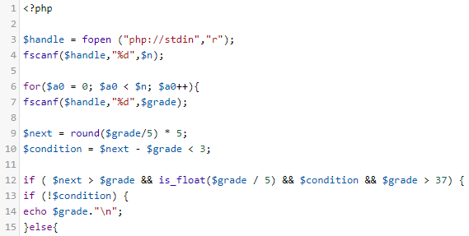

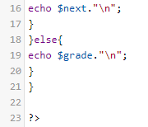

1. [**Time Conversion**](https://www.hackerrank.com/challenges/time-conversion)

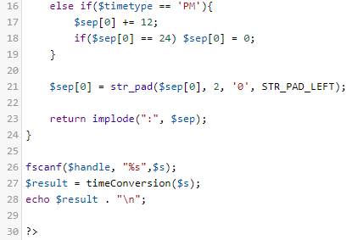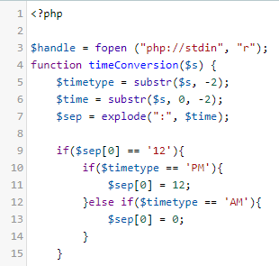

1. [**Birthday Cake Candles**](https://www.hackerrank.com/challenges/birthday-cake-candles)

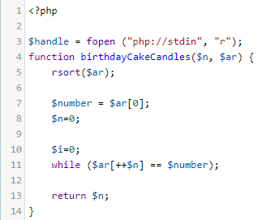

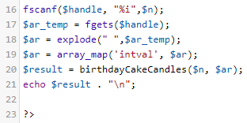

1. [**Mini-Max Sum**](https://www.hackerrank.com/challenges/mini-max-sum)

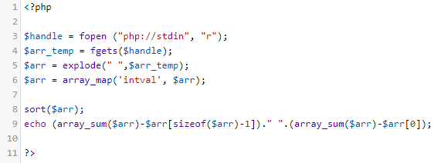

1. [**Staircase**](https://www.hackerrank.com/challenges/staircase)

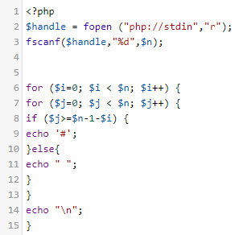

1. [**Plus Minus**](https://www.hackerrank.com/challenges/plus-minus)

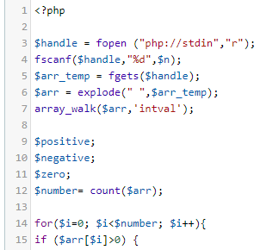

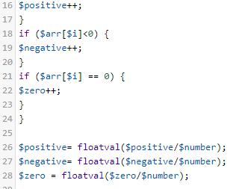

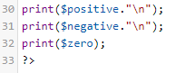

1. [**Diagonal Difference**](https://www.hackerrank.com/challenges/diagonal-difference)

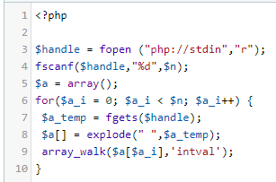

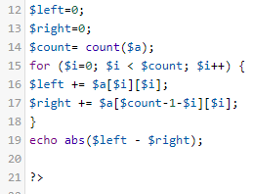

1. [**A Very Big Sum**](https://www.hackerrank.com/challenges/a-very-big-sum)

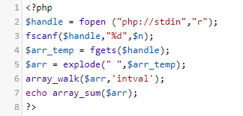

1. [**Compare the Triplets**](https://www.hackerrank.com/challenges/compare-the-triplets)

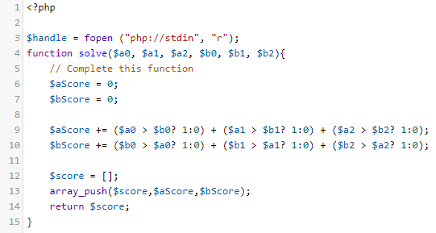

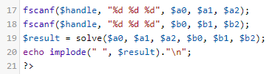

1. [**Simple Array Sum**](https://www.hackerrank.com/challenges/simple-array-sum)

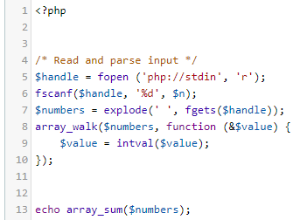

1. [**Solve Me First**](https://www.hackerrank.com/challenges/solve-me-first)

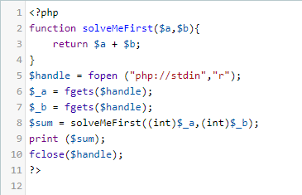

1. [**Sock Merchant**](https://www.hackerrank.com/challenges/sock-merchant)

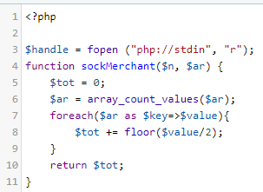

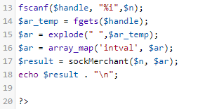

* **History submissions sesuai login anda masing-masing seperti berikut:**

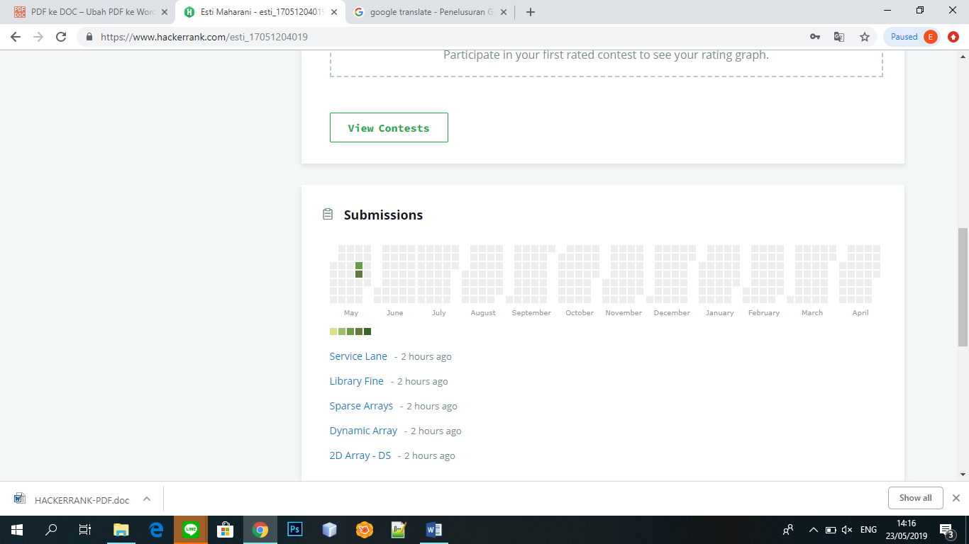

* **Score hackerrank :**

